ARM Cortex (STM32) based Solar Street Light
ABSTRACT
The main goal of this project is to implement an auto-intensity control of the LED-based-street light system that works on solar energy that helps conserving the electrical power of this street lighting system. As traffic decreases slowly in late night hours, the intensity is reduced progressively till morning to save energy and, thus, the street lights are switched on at the dusk and then switched off at the dawn automatically. This process repeats every day.
The intensity can not controlled by the high intensity discharge (HID) lamp that is generally used in urban street lights. LED lights are the future of lighting, because of their low energy consumption and longer life. They are fast replacing conventional lights wherein the intensity control is possible by the pulse width modulation.
This proposed system uses an ARM-Cortex processor of the STM32 family and a battery for power supply. This project uses a solar panel to charge the battery whereas charge controller circuit controls the charging of the battery. A strings of LEDs are interfaced to the ARM-Cortex processor with the help of the MOSFET Switch.
The intensity control of the LED light is possible by varying the duty cycle from a DC source. A programmed ARM-Cortex MCU is engaged to provide different intensities at different times of night by using PWM technique. The charge controller is also used for protecting the battery from overload and deep-discharge.
This project in future can be enhanced by integrating the LDR to follow the switching operation precisely.

BLOCK DIAGRAM:

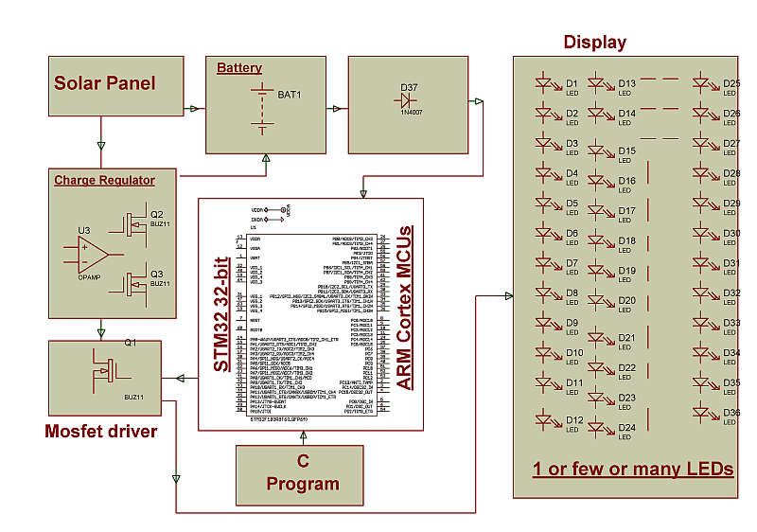

HARDWARE REQUIREMENTS:
STM32 with ARM cortex board, White LEDs,

MOSFET, Battery, Regulator, Solar Panel.

SOFTWARE REQUIREMENTS:
Keil compiler

Language: Embedded C

