Arduino based Solar Street Light

ABSTRACT:
The main goal of this project is to implement an auto intensity control of LED based street light system from solar energy for conserving the electrical power on the streetlight using Arduino board. As the traffic decreases slowly in late nights the intensity is reduced progressively till morning to save energy and thus, the street lights switch ON at the dusk and then switch OFF at the dawn automatically. The process repeats every day.
Intensity is not possible to be controlled for the high intensity discharge (HID) lamp which is generally used in urban street lights. LED lights are the future of lighting, because of their low energy consumption and long life and also they are fast replacing conventional lights where its intensity control is possible by the pulse width modulation.
This proposes system uses an Ardunio board and battery for power supply. In this project uses a solar panel to charge the battery. The charge controller circuit is used to control the charging. A string of LED’s are interfaced to the Ardunio board with help of a MOSFET switch.
The intensity control of LED light is possible by varying duty cycle from a DC source. A programmed Arduino board is engaged to provide different intensities at the different times of night using PWM technique. The charge controller is used for protect the battery from overload and deep discharge protection.
This project future can be enhanced by integrating the LDR to follow the switching operation precisely.

BLOCK DIAGRAM:

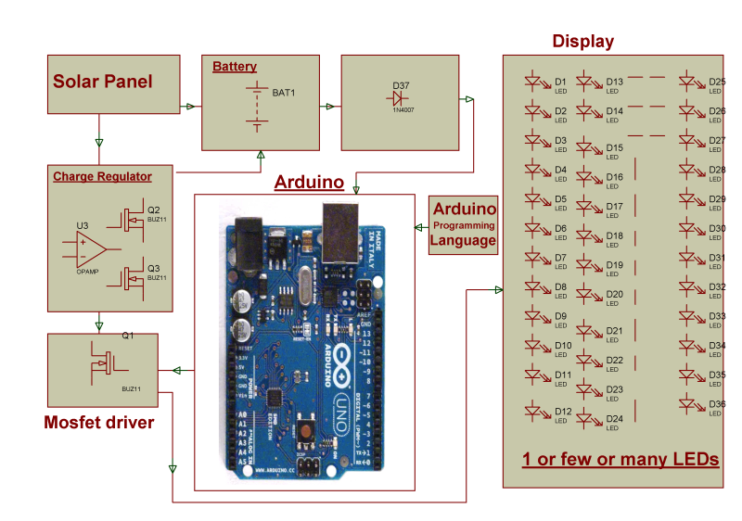

HARDWARE REQUIREMENTS:
Arduino board, White LEDs,

MOSFET, Battery, Regulator, Solar Panel.

SOFTWARE REQUIREMENTS:
Arduino Software
Language: Arduino Programming Language

