Arduino based Underground Cable Fault Detection

ABSTRACT
The project is intended to detect the location of fault in underground cable lines from the base station in kilometers using an Arduino board.This project uses the standard concept of Ohms law i.e., when a low DC voltage is applied at the feeder end through a series resistor to the Cable lines, then current would vary depending upon the location of fault in the short circuited cable.
In the urban areas, the electrical cables runs in undergrounds instead of overhead lines. Whenever the fault occurs in underground cable it is difficult to detect the exact location of the fault for process of repairing that particular cable. The proposed system finds the exact location of the fault.
This system uses an Arduino board and a rectified power supply. Here the current sensing circuit made with combination of resistors are interfaced to Arduino board with help of the internal ADC device for providing digital data to the microcontroller representing the cable length in KM’s. The fault creation is made by the set of switches. The relays are controlled by the relay driver IC which is used for switching the power sequentially to all the lines . A 16x2 LCD display connected to the microcontroller to display the information.
In case of short circuit (Line to Ground), the voltage across series resistors changes accordingly, which is then fed to an ADC to develop precise digital data to a programmed Arduino board that further displays fault location in kilometers.
The project future can be implemented by using capacitor in an ac circuit to measure the impedance which can even locate the open circuited cable.

BLOCL DIAGRAM:

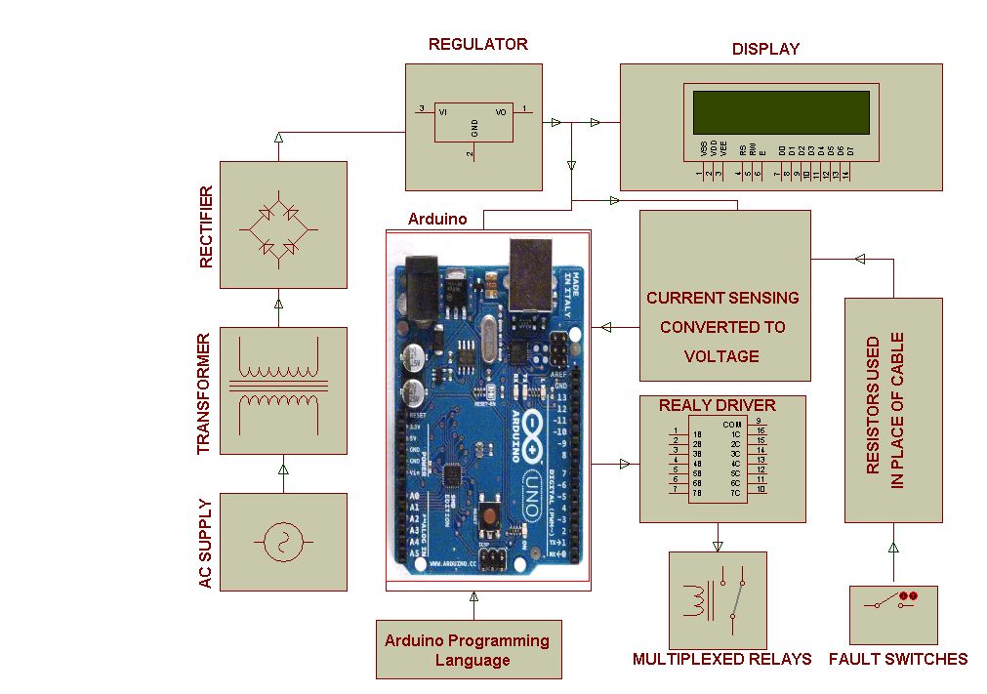

HARDWARE REQUIREMENTS:
LCD, Crystal, Relays, Relay Driver IC, Transformer, Diodes, Voltage Regulator, Resistors, Capacitors, LEDs, slide switches, Arduino board
SOFTWARE REQUIREMENTS:
Language: Arduino Programming Language.

