DESIGN AND IMPLEMENTATION 0F REAL TIME EMBEDDED TELE-HEALTH MONITORING SYSTEM

Abstract:

Now a day's healthcare industry is to provide better healthcare to people anytime and anywhere in the world in a more economic and patient friendly manner. In the present paper the physiological parameters such as ECG, Temperature are obtained, processed using Micro Controller and displayed on a LCD. If any vital parameter goes out of normal range then alert SMS will be sent to Doctor Mobile. This system is transferring data to system through RS-232 cable which low cost component to transmit ECG data to physicians for monitoring, diagnosis and patients care at a significantly low cost, regardless of patient's location.

Block Diagram:
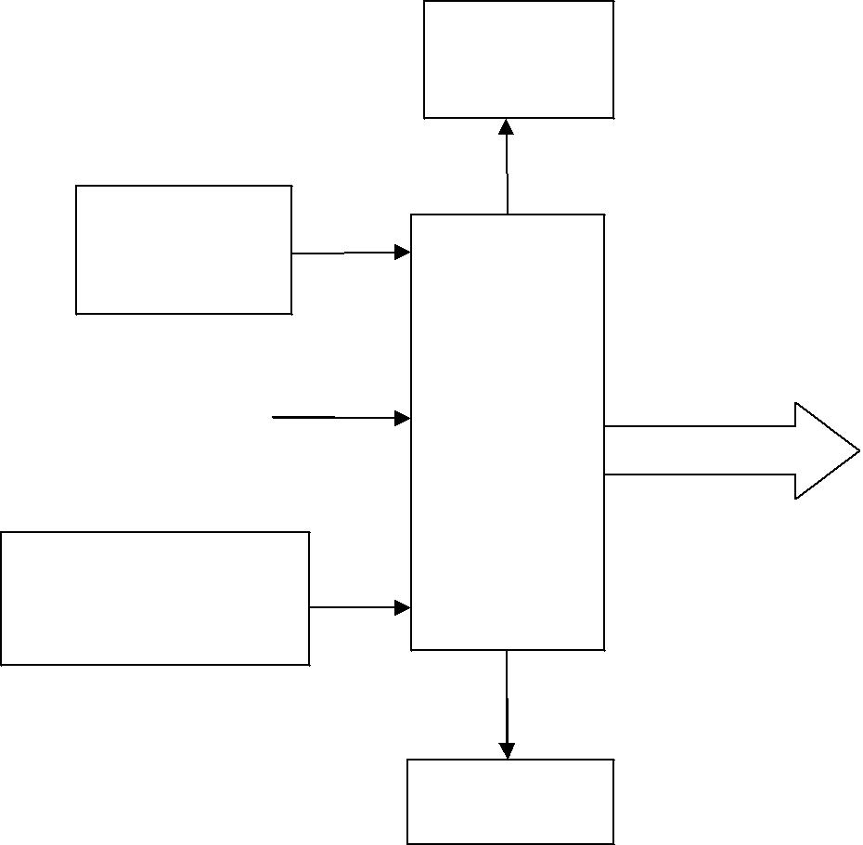
LCD

Display

Power

Supply

ECG | Micro
 | Micro |  | PC
Module | Controller | RS 232 Cable | PC

Body Temperature

Sensor

GSM modem

Scope:

- Interfacing ECG Module to Controller
- Interfacing GSM module to Controller
- Interfacing Body Temperature Sensor to Controller

- Interfacing LCD to Controller

Applications:

- We can use this technology in hospitals, in that we can monitor the heart rate &body temperature of the patients.

Software Requirements:

1. RIDE/KEIL (For Writing the Code)
- ISP/ LPC2000 Flash Utility (For Dumping the Code)

APPLICATION LANGUAGE: Embedded ‘C’

Hardware Requirements:

- Microcontroller
- Power Supply Unit
- LCD

- Body Temperature Sensor

- GSM

- ECG Module

- RS-232 cable

