Auto Power Supply Control from 4 Different Sources: Solar, Mains, Generator & Inverter to Ensure No Break Up Of Power

ABSTRACT
The main scope of this project is to ensure the consumption of the power supply from mains, generator, inverter and solar sources, optimally by using an appropriate programmed microcontroller in the most effective way. Emergency power systems are the types of systems that may include lighting, generators, fuel cells and other apparatus, to provide backup power resources in crisis or when the regular systems fail. They find uses in a wide variety of settings from residential homes to hospitals, scientific laboratories, data centers, telecommunication equipment and modern naval ships. Some homebrew emergency power systems use regular lead-acid based car batteries. Reduction of the system's power consumption extends the battery life, reduces system temperature and the system's fan noise as well. The Power consumption can be greatly improved from a stock distribution configuration to a fine-tuned system. The main objective of this project is to provide uninterrupted power supply to a load, by selecting the supply from any source out of 4 such sources: mains, generator, inverter and solar sources, automatically in the absence of any of the source.
In this setup, we use four switches to create the corresponding breakdown of that power supply source. When any of the switches is pressed, it shows the absence of that particular source. Switches are connected to the microcontroller as input signals. The commands of the microcontroller are fed to the relay driver IC, which switches appropriate relay to maintain uninterrupted supply to the load. It is indicated by using a lamp which fed through a single power supply from the mains initially. On the failure of this mains supply which has been actuated by pressing the appropriate switch, the load gets supply from the next available source – for instance, an inverter. If the inverter also fails, it switches over to the next available source, and likewise. The current status of this process gets displayed on the LCD, which is interfaced to the controller. As it is not feasible to provide all the 4 different sources of supply as indicated in the block diagram, one source only with alternate switches are provided to get the same function.

This setup can be further enhanced by using other sources like wind power and also by taking into consideration the best possible alternative power source whose tariff remains lowest at any given time.

BLOCK DIAGRAM

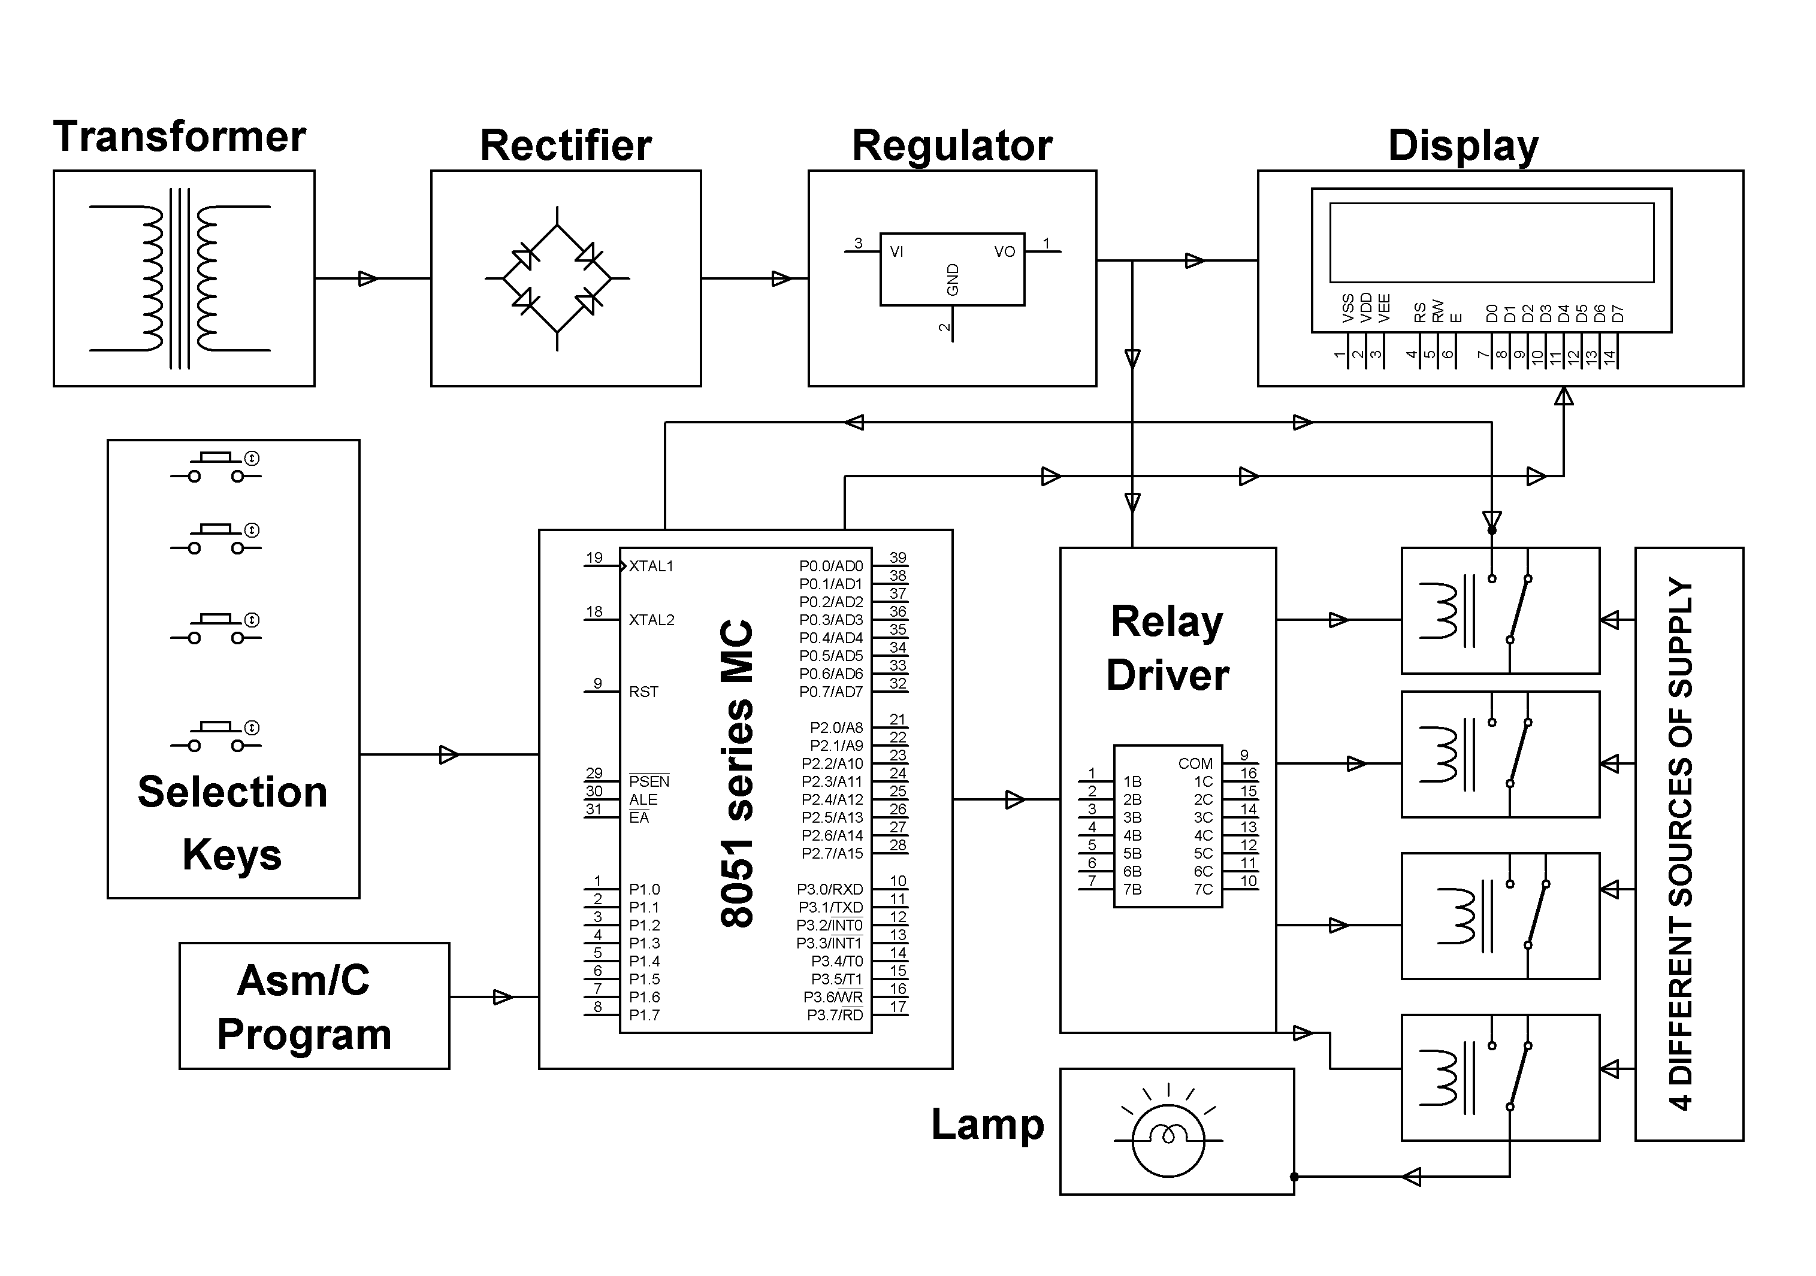
HARDWARE REQUIREMENTS:
8051 series Microcontroller, Relay Driver IC, Relays, LCD, Lamp, Push Buttons, Transformer, Diodes, Voltage Regulator, Crystal, LEDS, Capacitors, Resistors.
SOFTWARE REQUIREMENTS:
Keil compiler

Languages: Embedded C or Assembly

