EVM IN PIC

ABSTRACT
The project Electronic Voting Machine is an interesting project which uses PIC microcontroller as its brain. The project is designed for eight contestants but is expandable to many more. Voters can poll their vote to any one of the contestant. In this project one port is dedicated for push button switches for eight contestants and a master switch for polling officer. A simple yet powerful program is written in assembly language and is burned onto the microcontroller to accept votes and to retain count total of votes polled.
Polling officer switch (master) is provided to avoid multiple polling of single voter. Every voter should get approval from the polling officer. If the polling officer issues approval with his control switch, then only a voter can poll his vote. This issuance of approval is indicated by an long buzzer beep. Vote count is stored in EEPROM space of PIC microcontroller which is inbuilt in PIC and an LCD display is provided to display the total number of votes polled and individual contestant-vise votes polled. An erase button is also provided in order to make sure the contents of the EEPROM is zeroed before the start of the polling process. A buzzer is provided for audio effect of switch bounce. Whenever a switch is bounced, the system acknowledges the bounce by a short beep sound. This buzzer is driven by an NPN transistor. If voter tried to multiple polling a long beep sound is generated.
Further the project can be extended by adding a GSM/WIFI module which eases the operation of voting by sending a simple SMS over the network or access through a webpage over internet network.
BLOCK DIAGRAM
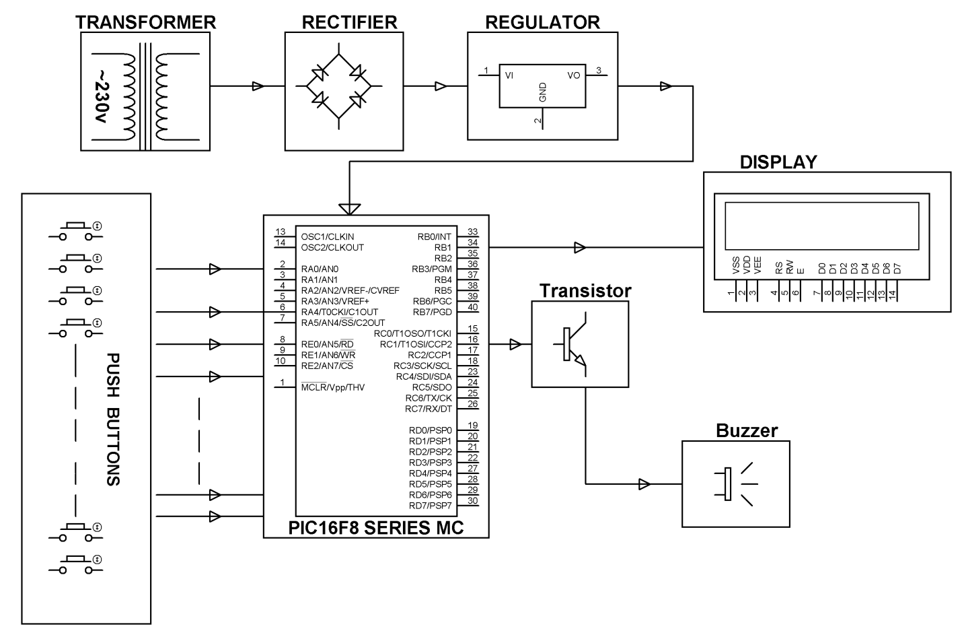

HARDWARE REQUIREMENTS:  PIC16F8 series Microcontroller, Push Buttons, Transistors, Transformer, Voltage Regulator, LED, LCD, Resistors, Capacitor | SOFTWARE REQUIREMENTS:  MPLAB & CCS C compiler  Languages: Embedded C or Assembly.

