EVM (ELECTRONIC VOTING MACHINE)

ABSTRACT

This is an interesting project which uses 8051 microcontroller as its brain. The project is designed for eight contestants. Voters can poll their vote to any one of the contestant. In this project, one port is dedicated for 8 push-button switches for eight contestants, and a master switch for polling officer.
A simple yet powerful program is written in assembly language and is burnt onto the microcontroller to accept votes and to keep counting the total votes polled. A Polling-officer switch (master) is provided to avoid multiple polling by a single voter. Every voter gets approval from the polling officer. If the polling officer issues approval with his control switch, then only the voter can poll his vote. This issuance of approval is indicated by a long buzzer beep. Vote count is stored in EEPROM and an LCD display is provided to display the total number of votes polled and individual contestant-vise votes polled. An Erase button is also provided in order to make sure the contents of the EEPROM is zeroed before the start of the polling process. A buzzer is provided for audio effect of the switch bounce. Whenever a switch is bounced, the system acknowledges the bounce by a short beep sound. If a voter tries to poll multiple times a long beep sound is generated.
The project can be extended by adding a GSM/WIFI module which eases the operation of voting by sending a simple SMS over the network or access through a Webpage over the internet network.

BLOCK DIAGRAM

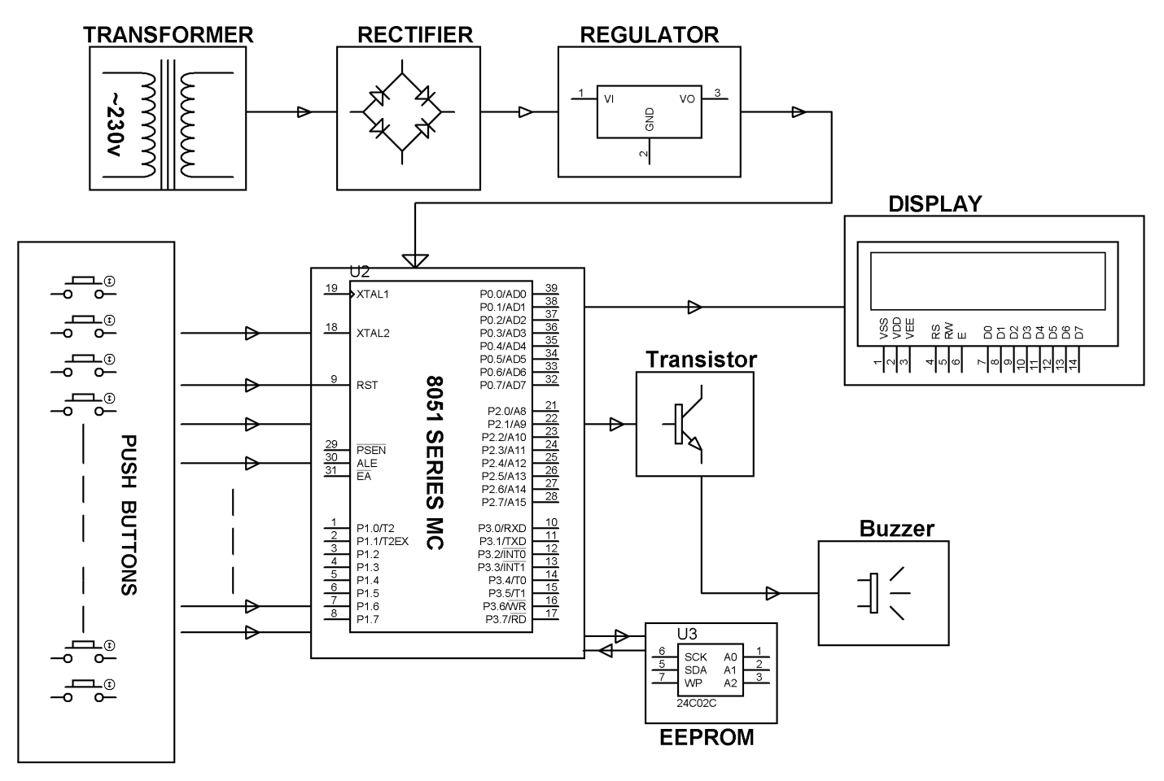
SOFTWARE REQUIREMENTS:
Keil compiler
Languages: Embedded C or Assembly.
HARDWARE REQUIREMENTS: 8051 series Microcontroller, Push Buttons, Transistors, Transformer, Voltage Regulator, LED, LCD, Resistors, Capacitor, EEPROM, Buzzer.

