Four Quadrant DC Motor Controls without Microcontroller

The main intention of this project is to control the speed of a DC motor in alternative directions using speed control unit and to operate the motor in four quadrants: ie, clockwise, counter clock-wise, forward brake and reverse brake.
This system uses an H-bridge motor drive IC for controlling the DC motor from corresponding switches used by the user for pressing. The four switches are connected to the circuit for controlling the movement of the motor. One slide switch interfaced to the circuit is for controlling the alternative direction of the DC motor. A 555 timers is used in the project to develop the required PWM pulses for speed control. The relays are used for changing the polarities of the motor as well as to apply brake to the motor. In the regenerative mode, the current is applied to the circuit in such a way that a revere torque is produced to stop the motor instantaneously .
The four-quadrant control of the DC motor is archived by the varying duty cycles from a 555 timer and their changing polarity with the H-bridge IC by appropriate switch pressing. The alternative speed control feature is achieved by a slide switch operation.
This project in future can be improved by using higher-power electronic devices to operate high- capacity DC motors. Regenerative braking for optimizing the power consumption can also be incorporated.

BLOCK DIAGRAM:

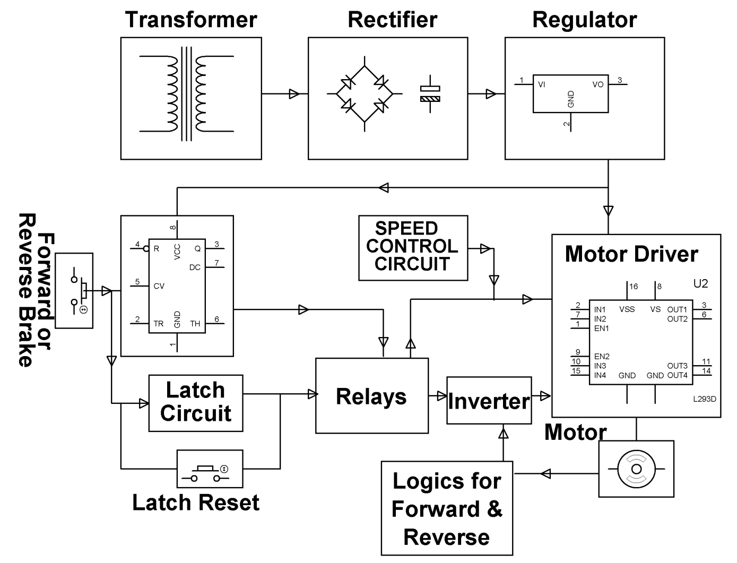

HARDWARE REQUIREMENTS:
Diodes, 555Timer, Relays, Transistors, Motor Driver IC, DC motor, Inverter IC, Push Buttons, Voltage Regulator, and Transformer.

