INTENSITY CONTROLLED ENERGY SAVING
LED STREET LIGHTS

ABSTRACT
White Light Emitting Diodes (LED) replace HID (high Intensity discharge) lamps in street lighting system to include dimming feature. A Microcontroller of the 8051 family is used to control the intensity by developing pulse width modulated signals that drives MOSFET to switch a LED bank accordingly to achieve desired operation.

LEDs consume less power and its life span is more, as compared to the conventional HID lamps. LEDs intensity can be controlled as per the requirement during the off-peak hours which is not feasible in HID lamps. Cluster of LEDs are used to form street light.

Microcontroller contains programmable instructions that control the intensity of lights based on PWM (Pulse width modulation) signals generated. The intensity of lights is kept high during peak hours, as traffic on roads tend to decrease slowly in late nights; the intensity also decreases progressively till morning. Finally the lights are completely shut down at morning 6am, and again resuming at 6pm in the evening and, this process is repeated.

This concept in future can be enhanced by integrating it with a solar panel that converts solar intensity into corresponding voltage, and this energy is used to feed the highway lights.

BLOCK DIAGRAM

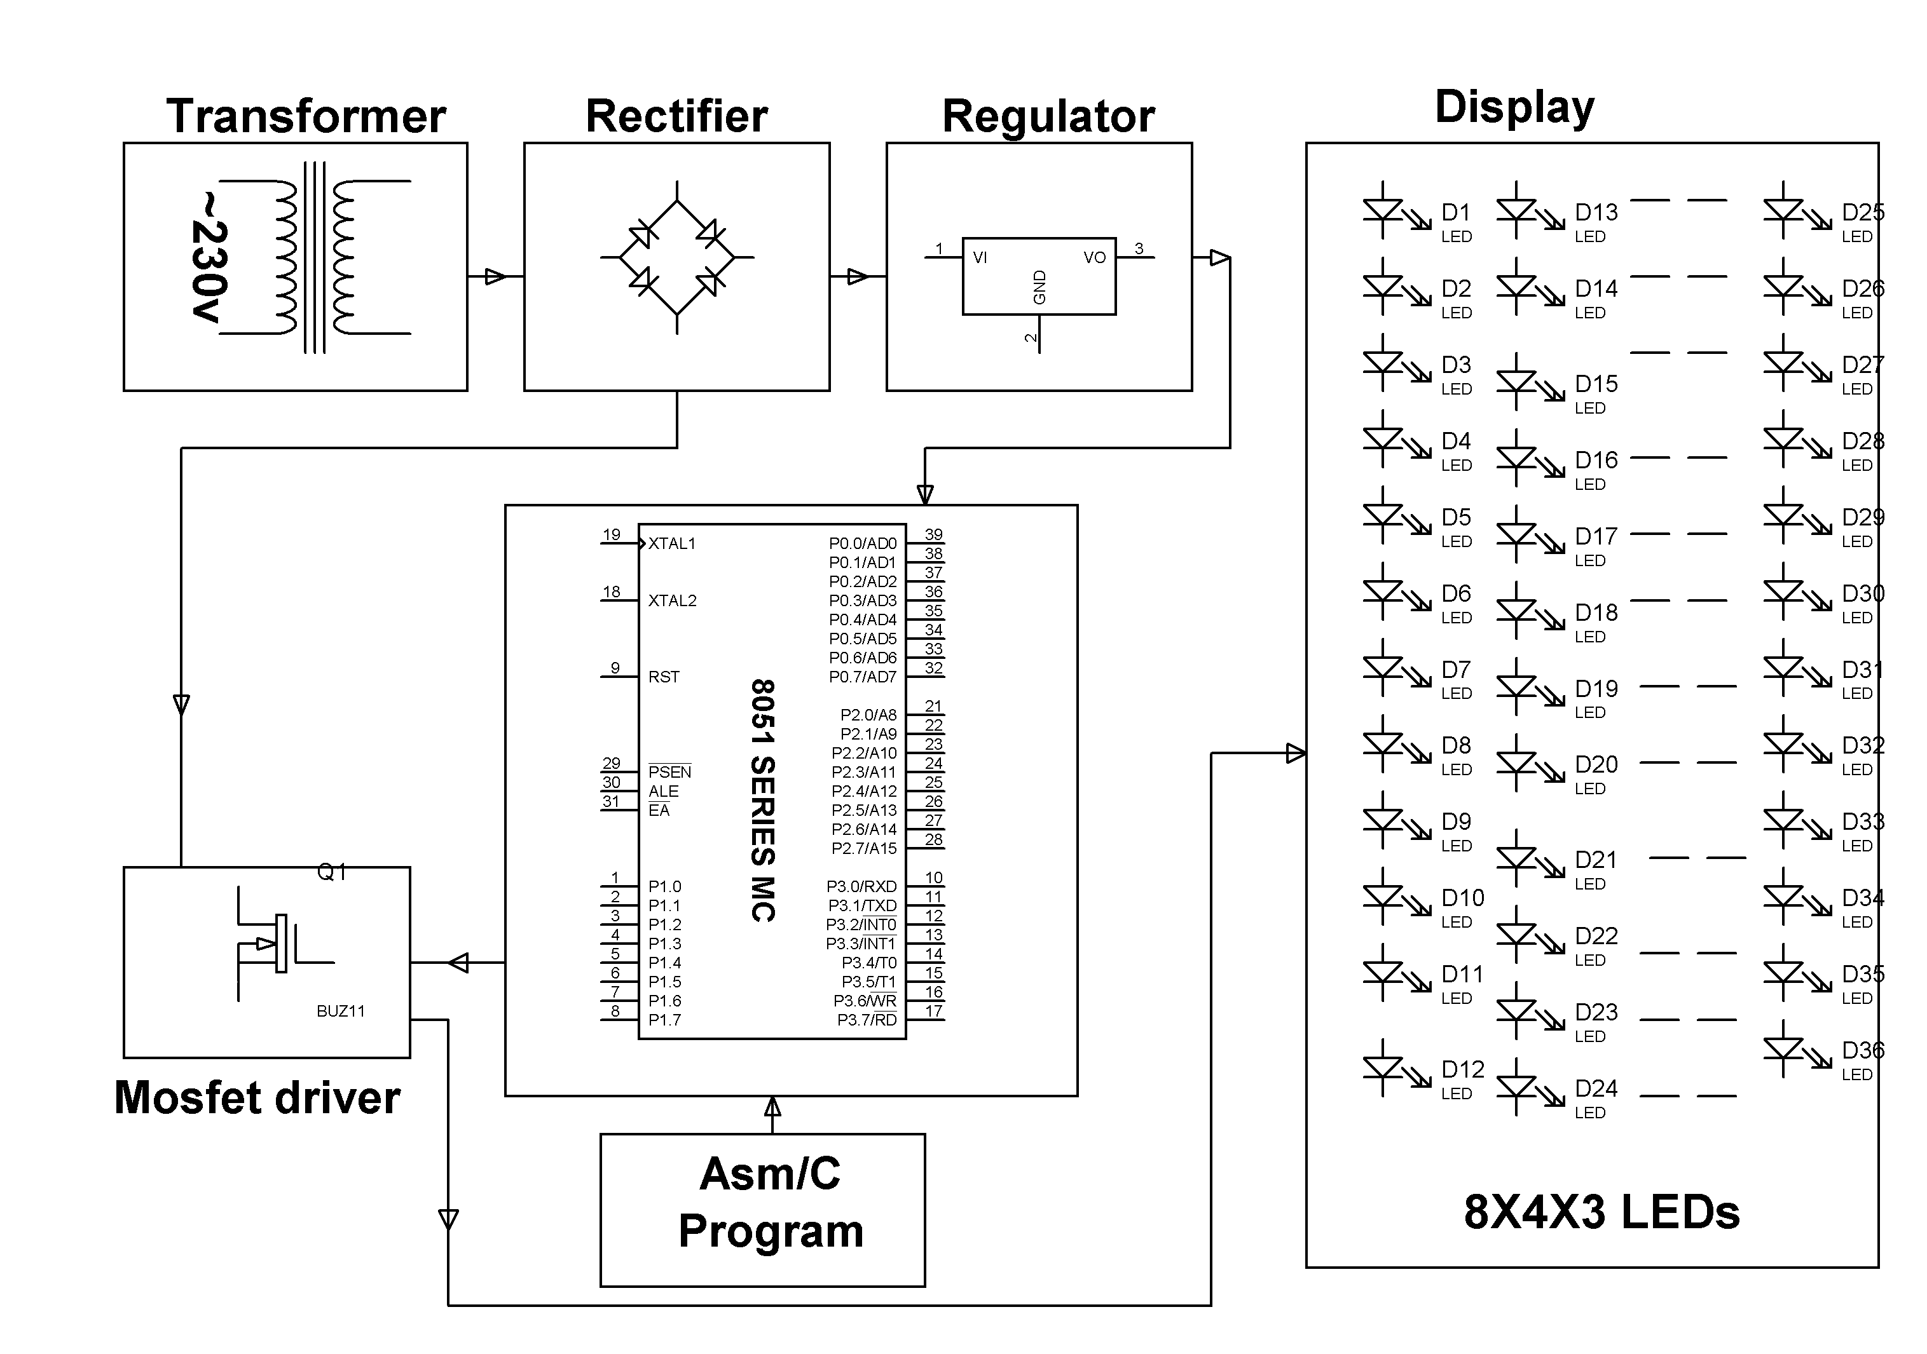
HARDWARE REQUIREMENTS:
Transformer, Diodes, Capacitors, Resistors, LEDs, 8051 series Microcontroller, White LEDs, Mosfet, Crystal.
SOFTWARE REQUIREMENTS:
Keil compiler

Language: Embedded C or Assembly.

