MUSIC TONE BASED DANCING LEDs

ABSTRACT
This project is intended to design musical-tone-based dancing LEDs those illuminate in synchronization with the music tone played or speech .
This system uses a microphone through which the musical sound is picked up and amplified. Then this amplified signal triggers a sequence of LEDs through an intermediate circuit. Hence, flashing of LEDs happens when an audio music constantly changes its beat. As a result a rhythmic sequence of changing LEDs appear with the changing beat of the music.
In future the project can be enhanced by using TRIACs and Opto-Isolators to use high power lamps in place of LEDs.

BLOCK DIAGRAM

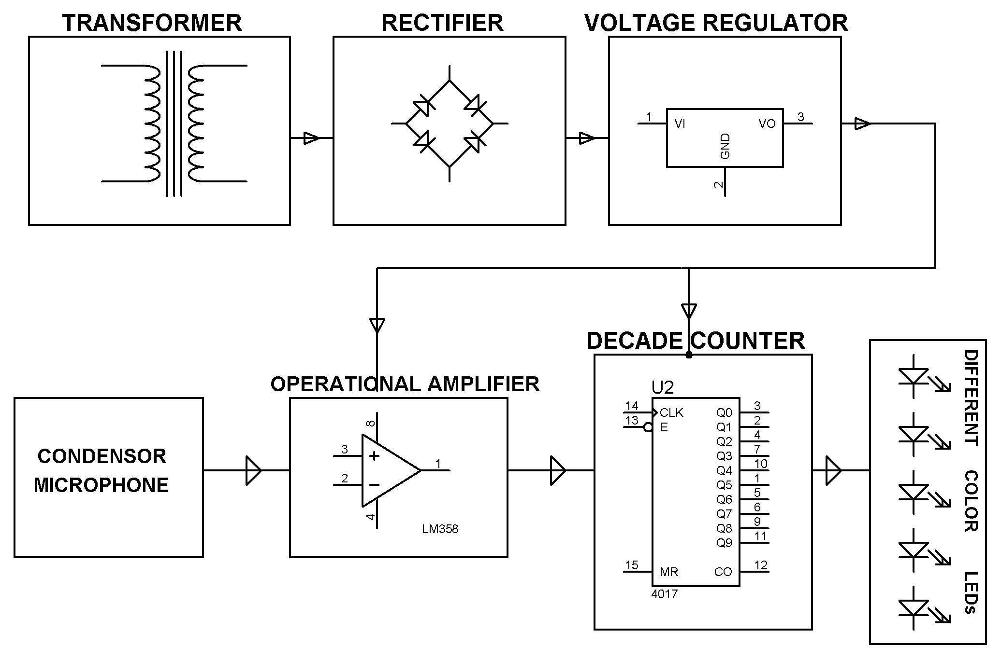

HARDWARE REQUIREMENTS:
Decade counter IC, OPAMP, Transistors, Potentiometers, Condenser Microphone, diodes, LED’s, capacitors, resistors.

