PC BASED ELECTRICAL LOAD CONTROL
ABSTRACT

The aim of this project is to control electrical appliances through a personal computer (PC). For example, theatre lighting can be centrally controlled form PC for a better stage management. Presently, these are manually managed which makes it difficult to coordinate the lighting with respective scene. With this system, one can control electrical appliances on/off by just being seated at one place using a PC.

This system is integrated with the electrical loads and also connected to the PC where in centralized control takes place. It uses an RS-232 protocol from a microcontroller to communicate with the PC. To turn on/off the appliances, we use “DAQ System” (software) which is loaded on the computer; and, a window apparently shows the loads on and off buttons – by using which, one can easily operate / control loads through relays interfaced to the microcontroller..
This project can be further enhanced by implementing a GUI based control panel on the PC with appropriate embedded software. The intensity control can also be incorporated using power electronics devices.
Note: The project works only on operating systems (E.g. Windows XP). The computer must have a RS232 serial port.
BLOCK DIAGRAM

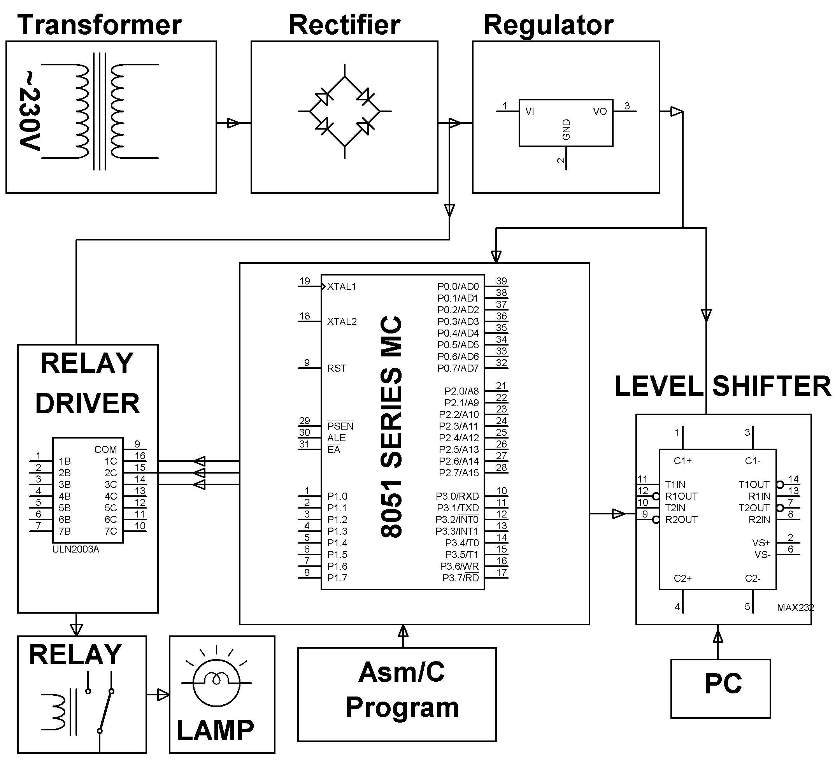
HARDWARE REQUIREMENTS:
8051 series Microcontroller, Level Shifter IC, DB Connector, Relays, Relay Driver, Transformer, Diodes, capacitors, Resistors, LED, Crystal, Lamps.

SOFTWARE REQUIREMENTS:
Keil compiler

Language: Embedded C or Assembly

