PREPAID ENERGY METER

ABSTRACT
The concept of electronic energy meters has been introduced in the power sector to effectively record the units consumed for billing purposes and also monitor several other factors to reduce power theft and minimize losses that occurs due to conventional electromechanical energy meters. This is a multipurpose project that integrates all the functions including a prepaid billing arrangement and automatic message sending system to the utility company. It may please be noted that it is truly not a usable commercial product engaging actual prepaid card but uses a set of switches for understanding the technology implemented behind it.
This project uses an 8051 microcontroller to which a GSM modem is interfaced .From here the message is sent to the phone number that is auto saved by giving a missed call to the SIM number present in the GSM modem. There are a set of pushbuttons, which are used to load, any recharge amount required. Such arrangement is in lieu of an actual prepaid card for demo purposes. By pushing those buttons one can easily recharge the amount. As soon as the microcontroller receives any recharge amount, a switch is set , to deliver power to the load. Thereafter consumption of the load power is calculated by the energy meter, which is interfaced to the microcontroller through an Optical Isolator IC. The microcontroller program then starts to deduct the recharge amount as per the consumption of load power. Once the recharge amount reaches to zero then the microcontroller cuts the power supply to the load through a relay driven duly by a NPN transistor and also sends a message to the phone number stored that contains all the billing information.
The concept can further be extended by integrating a RFID smartcard wherein each card is provided to automatically recharge the amount and send the same information via GSM module to the respective phone number stored.

BLOCK DIAGRAM

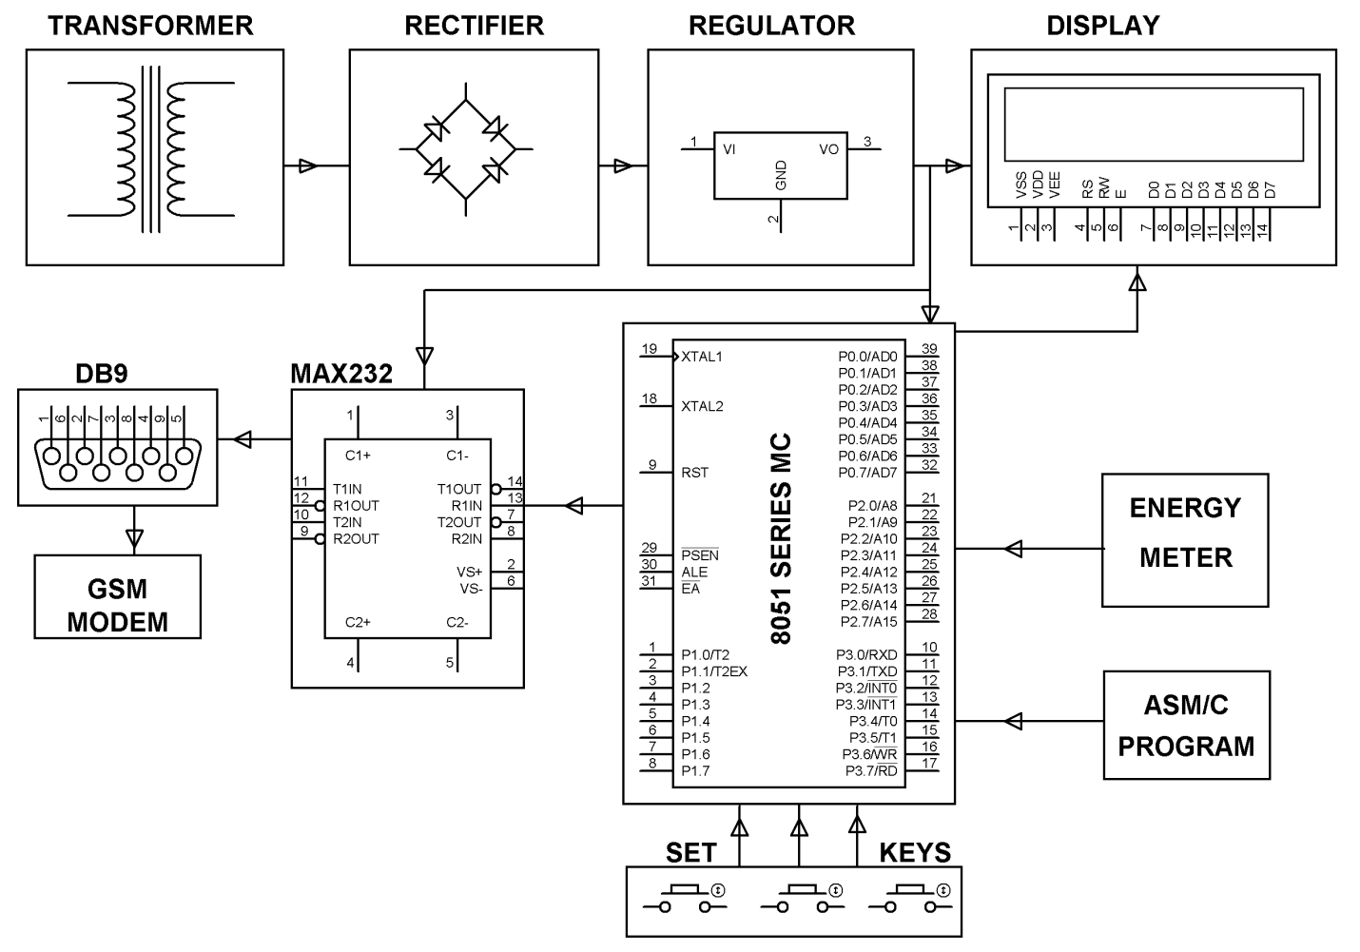
HARDWARE REQUIREMENTS:
Microcontroller (AT89C52/S52), Max232, GSM module, LCD(16x2), LED, Crystal Oscillator, Resistors, Capacitors, Diodes, Transformer, Regulator, Opto Isolator, Energy Meter, Lamp, push buttons.

SOFTWARE REQUIREMENTS
Keil compiler, Language: Embedded C
Or Assembly

