PROGRAMMABLE DECORATION LIGHT

ABSTRACT
The project is designed for decorative lighting or fancy lighting purposes which are used in malls, commercial establishments , festival places and on many other occasions.
Lighting has an important role to play in today’s world and it acts as a crowd puller for commercial establishments wherein drawing public attention is vital. It showcases the product display in a very attractive manner for people to notice and get attracted. In order to achieve such a lighting, this project is designed where number of LEDs are used as source for lighting. Additionally IR sensors are used instead of conventional switches to select desired effect. White light emitting diode (LED) based lamps are used for the purpose.IR sensors used in this project provide input command to the microcontroller for switching on or off the LEDs. The project uses an 8051 series microcontroller.
Furthermore, the project can be enhanced by using appropriate sensors and a cluster of various other color leds to have an amazing lighting effect.

BLOCK DIAGRAM
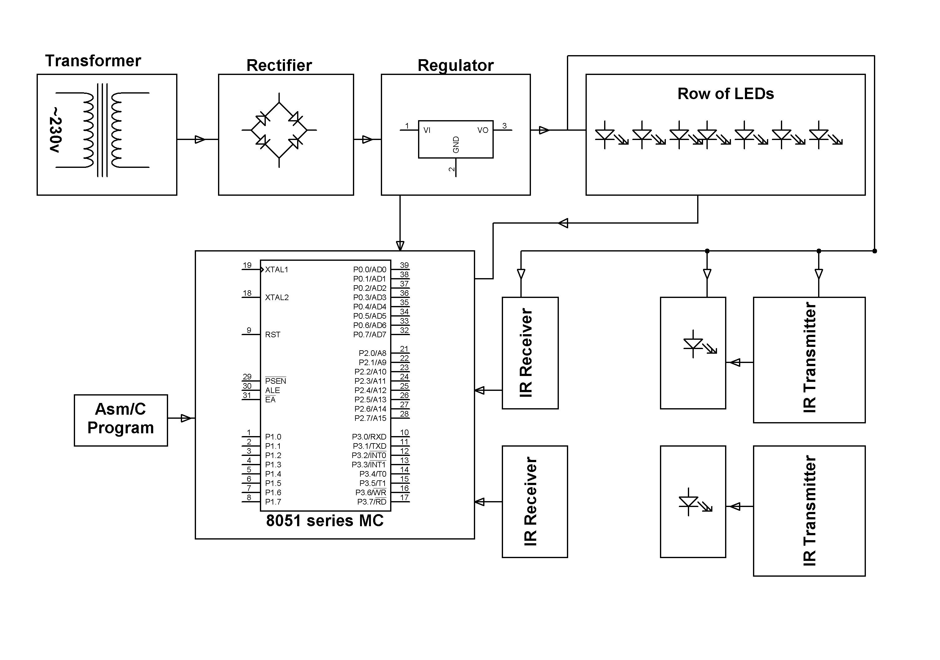

HARDWARE REQUIREMENTS:

8051 series Microcontroller, LEDs, Voltage Regulator, Resistors, Capacitors, Crystal, Transistors, Diodes, Photodiodes, IR LED
SOFTWARE REQUIREMENTS:

Keil compiler

Language: Embedded C or Assembly

