Raspberry Pi based Programmable Sequential Switching

ABSTRACT
The main concept of this project is to control the industrial loads sequentially in three modes: automatic, manual and pre-set modes by using relays with programmed Raspberry Pi development board.
In industries, many tasks require some repeated operation with specified time intervals, which is possible by Programmable logic controllers, but these are expensive for simple operations like sequential switching of loads. This project is proposed to switch the electrical loads sequentially by programmed instructions.
The proposed system uses a Raspberry Pi board and a rectified power supply. Monitor and keyboard is connected to the Raspberry Pi board so that a user can set timings of loads and can modify the program. In this system, the relays are controlled by the relay-driver IC, which is connected to the Raspberry Pi board. The lamps are connected to the relay contacts for indication purpose.
As mentioned above, the set mode is operated by the timers based on the input time set by the user, auto-mode works on default time settings as per the program and the manual mode is operated by the user with respective key-buttons that are required to be pressed on the keyboard.All the modes of load status are displayed on a TV or PC monitor.

BLOCK DIAGRAM:

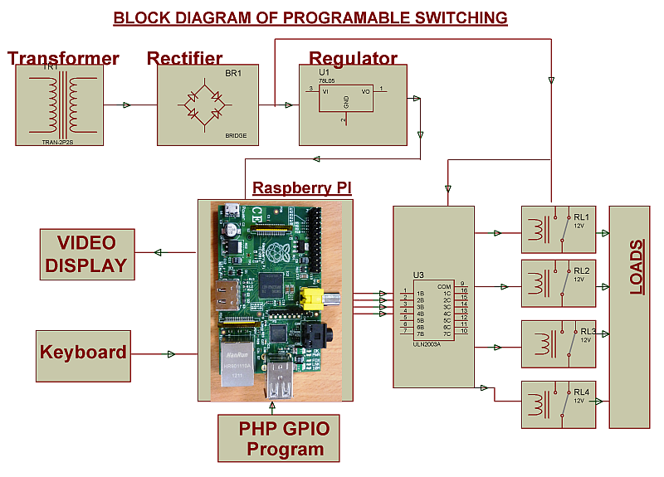
SOFTWARE REQUIREMENTS:
PHP GPIO program

HARDWARE REQUIREMENTS:
Raspberry Pi board, PC monitor or TV, Relay Driver, Relays, Resistors, Capacitors, LEDs, Crystal, Diodes, Transformer, Voltage Regulator, Push Buttons, Lamps.

