Raspberry Pi based Solar Street Light
ABSTRACT
The main goal of this project is to implement an auto-intensity control of the LED based street light system that uses solar energy to conserve the electrical power on the street light by using Raspberry Pi board. As the traffic decreases slowly in late night hours, the intensity is reduced progressively till morning to save energy, and thus, the street lights remain switched on at the dusk, and then switch off at the dawn, automatically. The process repeats every day.
The intensity is not possible to be controlled by the high intensity discharge (HID) lamp, which is now used in urban street lights. LED lights are the future of lighting, because of their low energy consumption and long life. As LED lights are fast replacing conventional lights, their intensity control is possible by the pulse width modulation.
This proposed system uses a Raspberry Pi board and battery for power supply. In this project, a solar panel is used to charge the battery. A charge controller circuit is used to control the charging. A string of the LED are interfaced to the Raspberry Pi board with the help of a MOSFET device.
The intensity control of the LED light is possible by varying the duty cycle from a DC source. A Raspberry Pi board is engaged to provide different intensities at the different times of night using PWM technique. A charge controller is used for protecting the battery from overcharging, overload and deep discharge protection.
This project in future can be enhanced by integrating the LDR to follow the switching operation precisely.

BLOCK DIAGRAM:

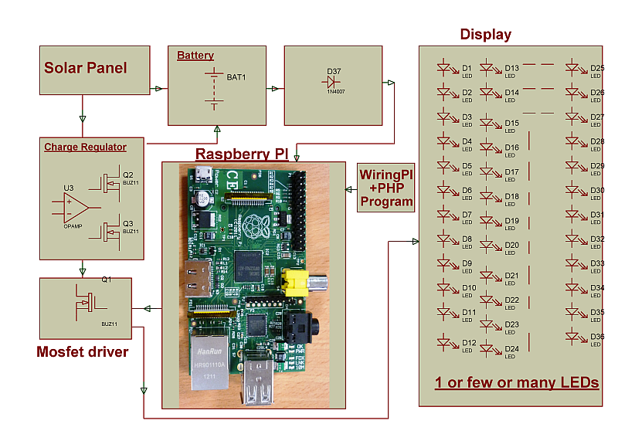
SOFTWARE REQUIREMENTS:
Wiring Pi + PHP program
HARDWARE REQUIREMENTS:
Raspberry Pi board, PC monitor/ TV,White LEDs,

MOSFET, Battery, Regulator, Solar Panel.

