SOLAR POWERERD LED STREET LIGHT WITH INTENSITY CONTROL

ABSTRACT

The project is designed for LED based street lights with an auto-intensity control that uses solar power from photovoltaic cells. Photovoltaic panels are used for charging batteries by converting the sunlight into electricity. A charge controller circuit is used to control the charging, and an LDR is used to sense the ambient light on day time.
The intensity of street lights is required to be kept high during the peak hours. As the traffic on the road tends to decrease slowly at late nights, the intensity also gets reduced progressively till morning to save energy. Besides the same street lights are switched on at the dusk and then switched off at the dawn automatically by using an LDR sensing device LDR. The process repeats every day.
High Intensity Discharge lamps (HID) generally used for urban street light are based on the principle of gas discharge and thus the intensity is not controllable by any voltage reduction method as the discharge path gets broken. LED lights are the future of lighting, because of their low energy consumption and long life they are fast replacing conventional lights world over. White light emitting diode (LED) replaces the HID lamps where intensity control is possible by pulse width modulation. The intensity control helps in saving energy during late nights while traffic density on the street is low. A programmable microcontroller of the 8051 family is engaged to provide different intensities at different times of the night using PWM technique, for energy saving for solar based system, also using a charge controller for protecting the battery from over charging, overload and deep discharge protection. A light sensing device LDR (Light Dependent Resistance) is used , whose resistance reduces drastically in day light for sensing purposes.

Furthermore, the project can be enhanced by using time programmed dusk to dawn switching based on latitude and longitude of a specific location .
BLOCK DIAGRAM
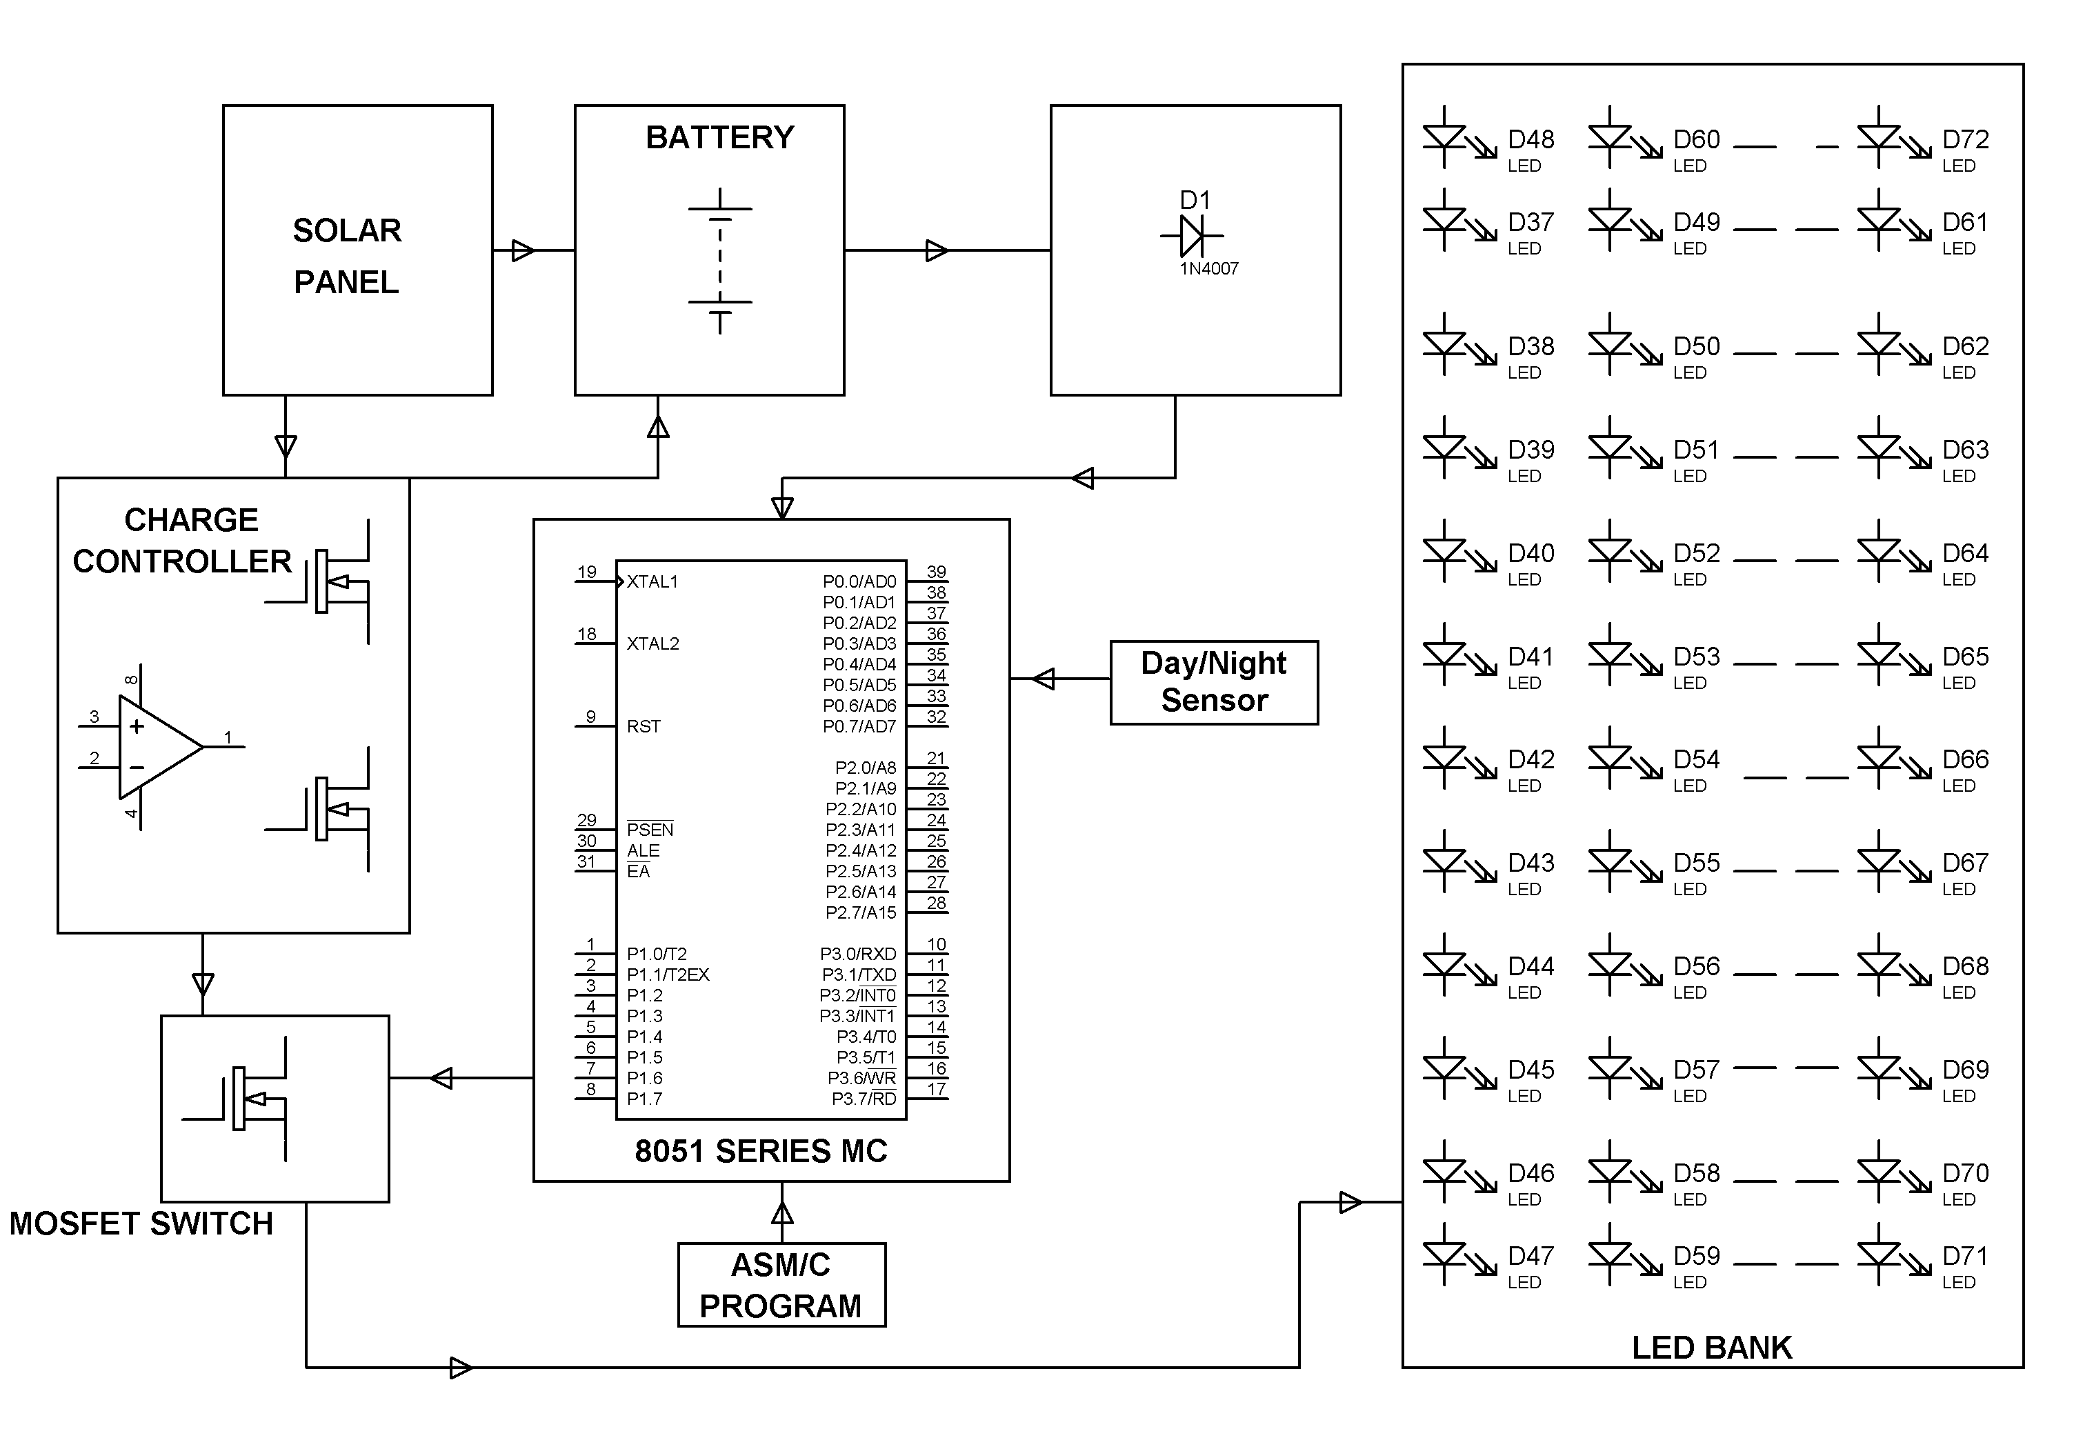

HARDWARE REQUIREMENTS:
8051 series Microcontroller, White LEDs,
MOSFET, Battery, Regulator, Solar Panel, Day/Night sensor.

SOFTWARE REQUIREMENTS:
Keil compiler

Language: Embedded C or Assembly

