System Design for Monitoring Infant Speech EmotionBLOCK

Abstract:

To alleviate worries of busy younger parents, this paper designs a system for monitoring infant speech emotion. The system distinguish infants’ cry from other voice (e.g. parents’ voice) by using speech emotion recognition. When the inputted speech signal is recognized as infant cry, it judges cry reasons (fever, urination, hunger) according to the signals from sensors and then take proper propitiatory measures (playing music or parents’ voices) to ease the infants. Finally, it sends the guardians a message or calls the guardians about cry reasons by the GSM module, so that humane guardianship for infant is realized. Experimental results show that the system realizes the aforementioned functions, and is a good partner for infant and an under servant for younger parents.

BLOCK DIAGRAM
Diaper Humidity

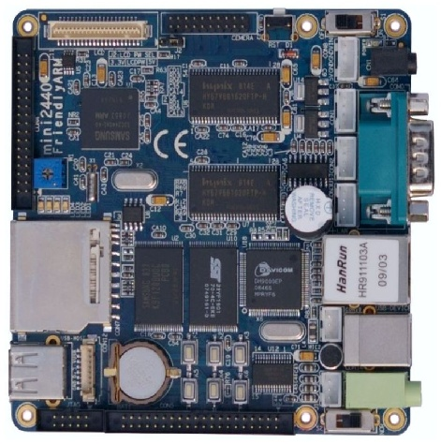
DC 12v Supply
Indoor Temperature

Body Temperature
MIC

HARDWARE:
- Friendly ARM Mini 2440 (Single-Board Computer) with 400 MHz Samsung S3C2440 ARM9 processor.

SOFTWARE:
- OS : Embedded Linux
- Language : C++
- IDE : Qt Creator

