VEHICLE MOVEMENT SENSING LED STREET LIGHT WITH OFF PEAK HOUR TIME DIMMING
ABSTRACT
The project is designed to detect vehicle movement on highways to switch on only a block of street lights ahead of it (vehicle), and to switch off trailing lights to save energy. This proposed system provides a solution for energy saving achieved by sensing an approaching vehicle, and then to switch on a block of street lights ahead of the vehicle. As the vehicle passes by, the trailing lights get switch off automatically. So, when there are no vehicles on the highway, then all the lights remain off.
However, there is another mode of operation wherein, instead of being switched off completely, the lights remain on with only 10% of intensity. As a vehicle approaches, the block of street lights switch to 100% intensity, and then, as the vehicle passes by, the trailing lights revert back to 10% intensity again. High intensity discharge lamp (HID) presently used for urban street lighting are based on the principle of gas discharge wherein the light intensity which is not controllable by any voltage reduction. White light emitting diode (LED) based lamps are soon replacing the HID lamps in street light. Intensity control is also possible by pulse width modulation (PWM) generated by the microcontroller.
A set of sensors used on either side of the road senses a vehicle movement and sends logic commands to the microcontroller to switch on/off the LEDs. Thus, this way of dynamically changing intensity helps in saving lot of energy. The project uses a PIC series microcontroller.
Furthermore, the project can be enhanced by using appropriate sensors for detecting the failed street lights, and then sending an SMS to the control department via a GSM modem for appropriate action.

BLOCK DIAGRAM

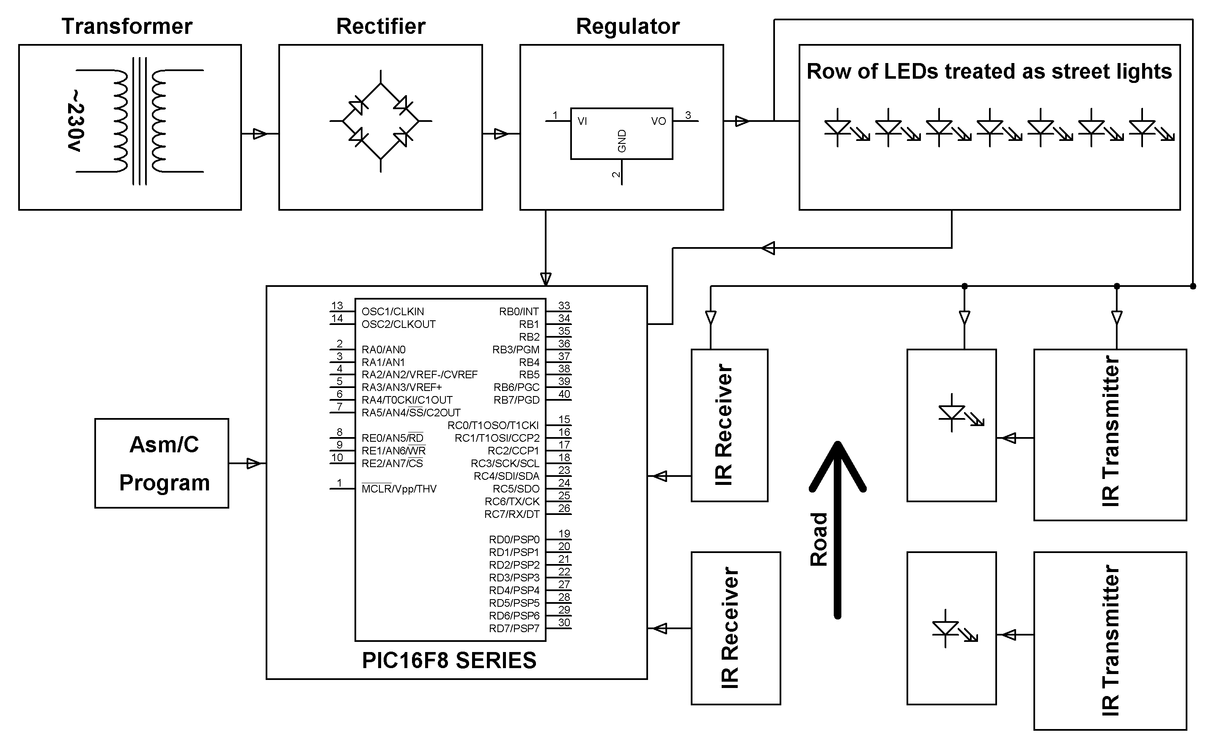

SOFTWARE REQUIREMENTS:
MPLAB & CCS C compiler
Language: Embedded C or Assembly.

HARDWRE REQUIREMENTS:
PIC16F8 series microcontroller, Transformer, Diodes, Resistors, Capacitors, Voltage Regulator, LEDs, IR LEDs, Photodiodes, Transistors.

