VIRTUAL DISPLAY OF MESSAGE BY PROPLLER DRIVEN LEDS
ABSTRACT
This project comprises of a circular display with a string of LEDs in propeller mode. Using high speed motor and some mechanical assembly, the LED string mounted on a printed circuit board duly interfaced to a microcontroller displays the message virtually.
An appropriate program executed drives a pair of single line LEDs in space multiplexing mode. This propeller system displays some message or a clock timing, taking advantage of persistence of vision of human eye. Without a single line of LEDs in space multiplexing mode if one had to displaya message,the number of LEDs as high as 525 would have to be used. In this project there are only 10 X 2 set of LEDs. Thus, material count, hardware requirement, brings overall cost to very affordable price for a magnificent display. Synchronizing is implemented through software.

Block Diagram:
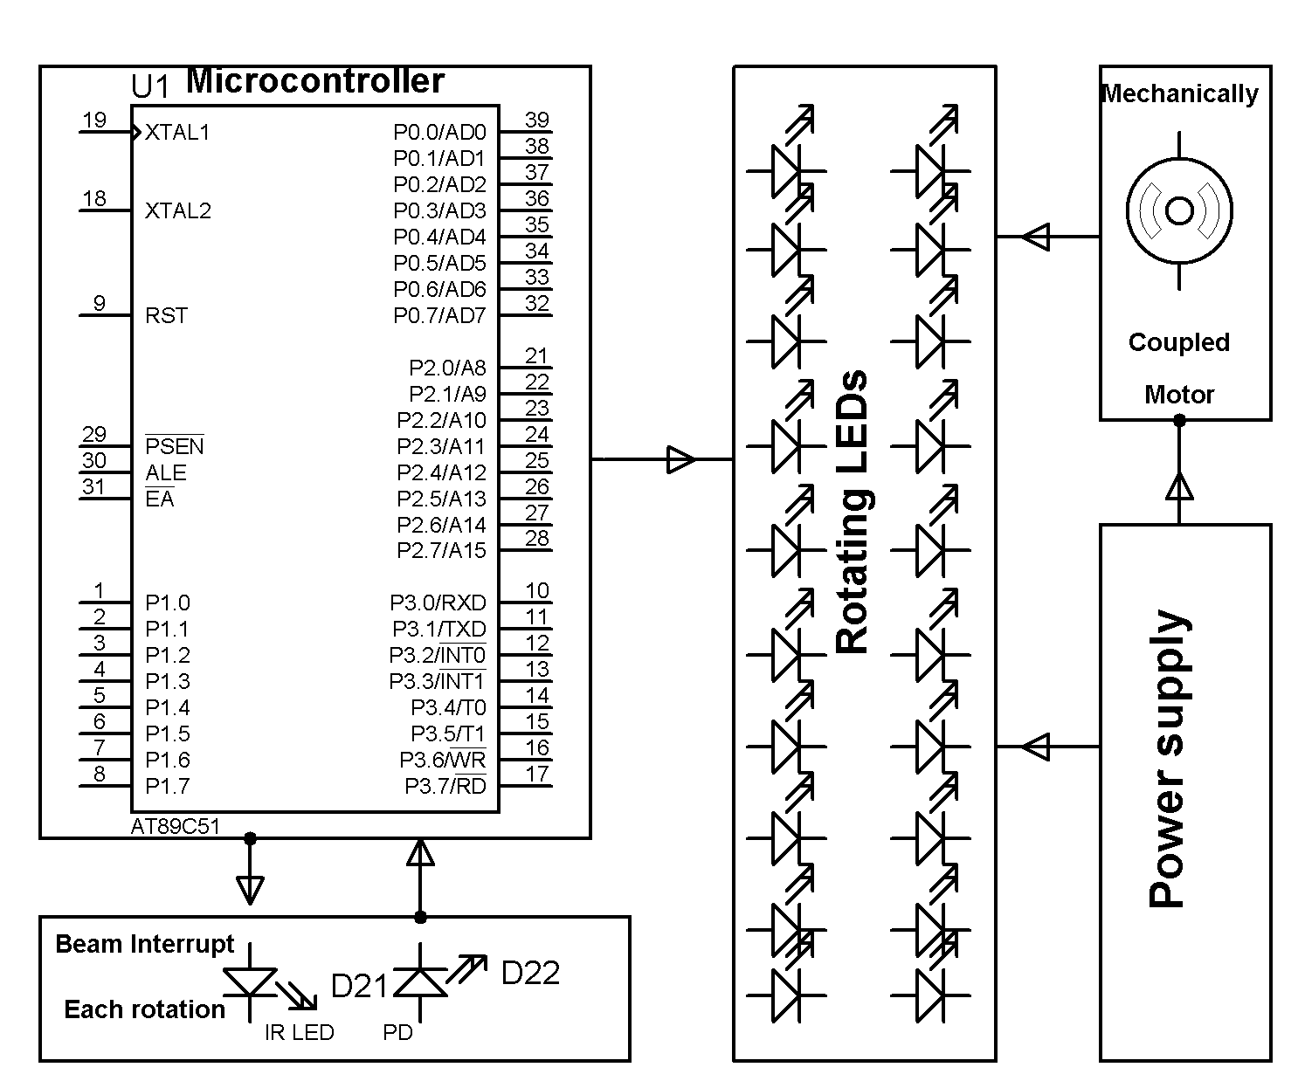
HARDWARE REQUIREMENTS:
Microcontroller, sensors, Resistors, Capacitors, Diodes, Transformer, VoltageRegulator, Transistors, LEDs, Motor

SOFTWARE REQUIREMENTS:
Keil compiler, Language: Embedded C or Assembly.

