VOICE CONTROLLED ROBOT by Android app

abstract

The project is designed to control a robotic vehicle by voice commands for remote operation. An 8051 series of microcontroller is used together with a a Bluetooth device interfaced to the control unit for sensing the signals transmitted by any Android application running cell phone.

Remote operation is achieved by any smart-phone/Tablet having Android OS upon a GUI (Graphical User Interface) based voice operation. The transmitting end uses an Android application through which the voice commands are transmitted to digital bits. At the receiver end, these commands are used for controlling the robot to make it move forward, backward, left or right. At the receiving end, two motors are interfaced to the microcontroller where they are used for the movement of the vehicle. Serial communication data sent from the Android application is received by the Bluetooth receiver interfaced to the microcontroller.

Furthermore, this project can be enhanced using DTMF technology. Using this technology we can control the robotic vehicle by using cell phone. This technology has advantages over long communication range as compared to RF technology.

BLOCK DI AGRAM

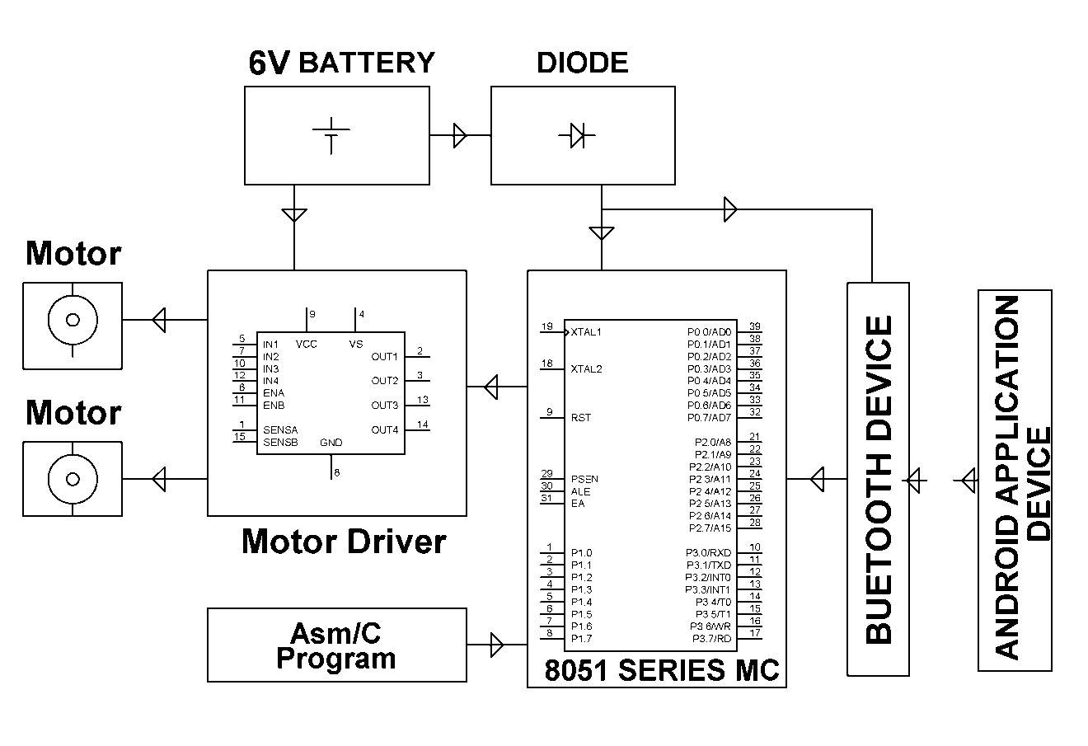

SOFTWARE REQUIREMENTS:

Keil compiler

Languages: Embedded C or Assembly

HARDWARE REQUIREMENTS:

8051 series Microcontroller, Push Button, Bluetooth module, Motor driver IC, DC motors, Resistors, Capacitors, Diodes,
Batteries,

