TANK WATER LEVEL CONTROLLER
ABSTRACT
The project is designed to give a display of water level in a tank and control a pump motor as required. The reading given is in the scale of 0 to 9. An 8051 family microcontroller is used in this project.
The circuit designed for overhead tank digital water level indicator with an LCD display is to show the rising/ falling water level in the tank. A relay is used to drive a motor off (demonstrating as a lamp here) whenever the tank exceeds its maximum level ie it automatically shuts down the Motor (demonstrating as a lamp here). The ground terminal of the sensor must be kept at the bottom of the container (tank).
The power supply consists of a step-down transformer 230/12V, which steps down the voltage to 12V AC. This is converted to DC using a Bridge rectifier. Ripples are removed using a capacitive filter, and it is then regulated to +5V using a voltage regulator 7805, which is required for the operation of different ICs and components.
Furthermore, the project can be enhanced by interfacing it with a buzzer to alert when the water level falls below a minimum level and then a GSM modem can be interfaced such that the readings can be sent remotely to a mobile phone, where the readings have a crucial role to play.

BLOCK DIAGRAM:
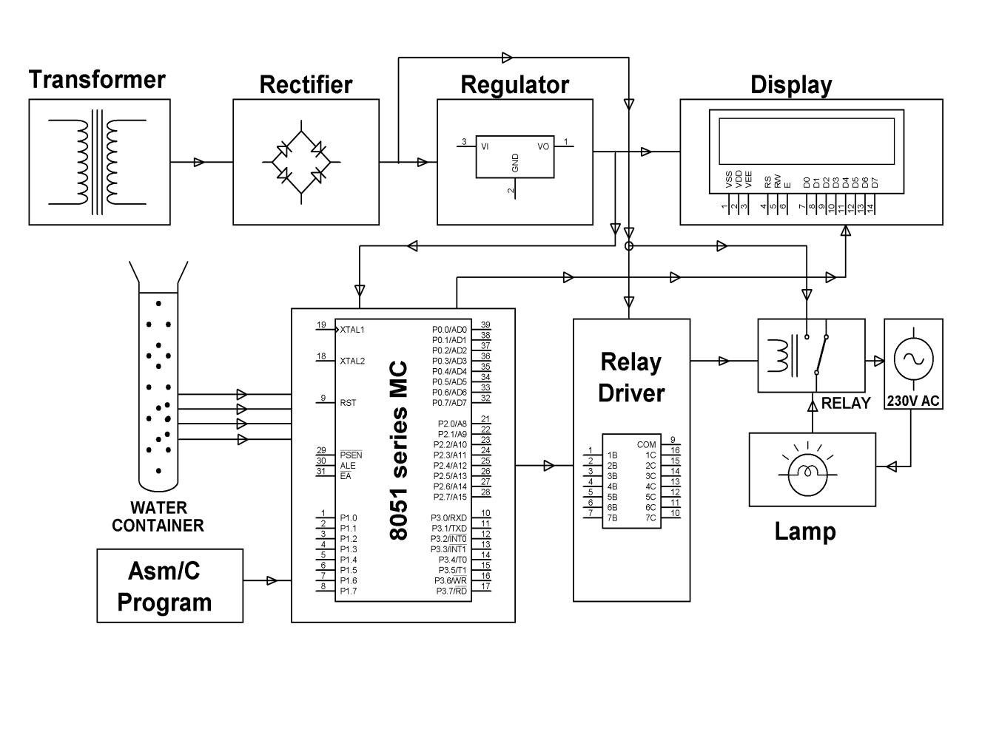
HARDWARE REQUIREMENTS:
Transformer, Diodes, Resistor, Capacitor, Transistor, 7-Segment Display, Encoder, Decoder

