WIRELESS POWER DRIVEN TRAIN
ABSTRACT
The project is designed to transfer power wirelessly to one or more DC motors for an electric car or train without requiring any fuel /battery or electrical connection to run it in a specified path by inductive resonance coupling at the ground level fixed coil developing a 40 KHz power from the mains AC source.

Wireless power transfer makes a remarkable change in the field of electrical engineering and eliminates the usage of conventional copper overhead wire for train. Based on this concept, the project is developed to transfer power to a robotic vehicle or electric car or electric train wirelessly. This project can also be used for high-power charging batteries in conventional electric cars wirelessly while on the run. Since charging of the battery is not possible to be demonstrated, the project has a robotic vehicle that runs totally through wireless power.
This project is built upon an high frequency PWM inveter circuit with a gate-driver IC to drive a MOSFET based half bridge system .It first converts AC 230V 50Hz to AC 18V using a step-down transformer and then that is converted to DC which powers the high frequency inverter. This output is fed to a tuned coil forming the primary of an air-core transformer. A high-frequency AC is fed to the primary coil with a capacitor to make a resonance tuned circuit. The primary coil is placed under the road that gets inductively coupled to the secondary coil mounted on the moving vehicle to wirelessly receive power to drive the robotic vehicle DC motor after being rectified.
Moreover, this technique can be used in number of other applications too such as to charge a mobile phone, iPod, laptop battery, and propeller clock ,or any moving object wirelessly. And also, this kind of charging provides a far lower risk of electrical shock as it would be galvanically isolated.

BLOCK DIAGRAM

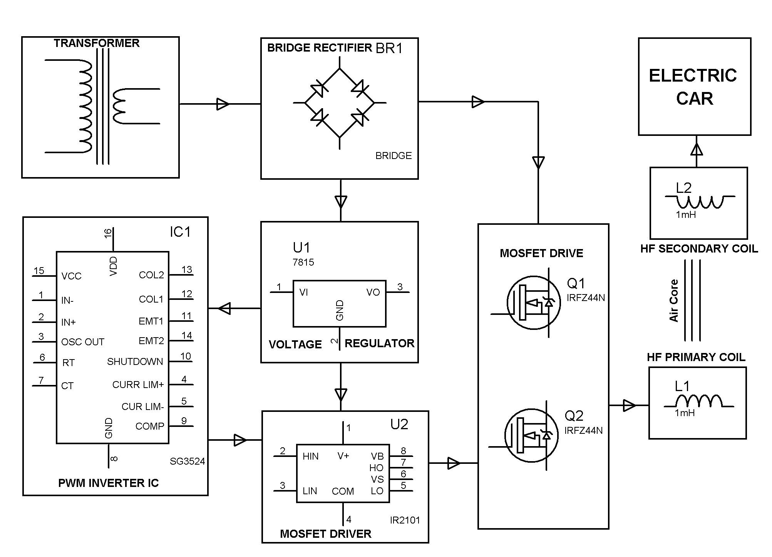
HARDWARE REQUIREMENTS:
HF-Transformer, HF-diodes, rectifier, Bridge-MOSFETs drive, Two air filled inductor coils, Voltage regulator, Electric car, MOSFET driver, PWM inverter IC

